Dipartimento di  Scienze Umane e Sociali | 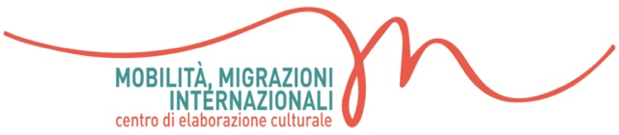 | Dottorato  in Studi Internazionali, L’Orientale
Application form
Summer School
“Interrogating Euro-Mediterranean Migration:
Cities, Environment, Asylum and Borders as Terrains of Conflict”
Procida 2022
MoMI (UNIOR)

Name:
Surname:
Affiliation:
Date and place of birth:
Current address:
Phone:
Email:

1) EDUCATION
Degree, PhD, Master (max. 500 words)

2) RESEARCH EXPERIENCE
Post-doc, research position and/or participation in research projects (max. 500 words)

3) ANY OTHER RELEVANT INFORMATION
(max. 500 words)

4) RELEVANT PUBLICATIONS AND CONFERENCE PAPERS
On the summer school themes (max. 5 titles)

5) RESEARCH PROPOSAL
An abstract of the work you intend to present / discuss at the Summer School (max. 500 words)

In compliance with the Italian legislative Decree no. 196 dated 30/06/2003, I hereby authorize you to use and process my personal details contained in this document.
Signature:
Place and date:

